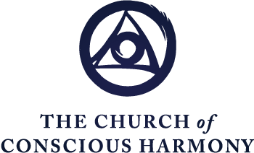

The Spiritual Journey
Formation in the Contemplative Christian Life
“The Beatitudes: Healing the Emotional Programs, Part 2”
Excerpted from
The Spiritual Journey Part 4, Paradigms of the Spiritual Journey

Fr. Thomas Keating

Blessed are those who hunger and thirst for justice, for they will be filled.
This beatitude that we were speaking about, “Blessed are those who hunger and thirst for justice,” is the fruit of that movement of the Spirit within us that urges us to take ourselves in hand and to have the courage to climb out of our over-identification and cultural conditioning, early religious training, as the case may be, ethnic group, insofar as these are obstacles to responding to the Gospel, or insofar as we see that they represent prejudice or bias or somebody else’s rather than our own response to Christ or to reality. This doesn’t mean that we reject our country, or our religious training, or our ethnic group, or our parents. It simply means that, while remaining grateful for all the good things we’ve received, and loyal in our service of the group, we recognize that this loyalty is not absolute. So that we can make necessary criticism or suggestions, or help to improve a situation, instead of a naive loyalty that refuses to see genuine defects or to disregard improvements or corrections that really should be made. It’s a freedom to remain within the tradition, within the institution, and, at the same time, a freedom to offer what suggestions can be made. It is not really possible to correct an institution or a tradition. We can only serve it. And it is by serving it that you correct it. In other words, it’s the disposition in which you respond to what you feel should be done, and at the same time have the inner freedom to realize that God’s time and place is not necessarily your time and place, and to do whatever we can positively to improve family, community, church or whatever situation without demanding the results or without insisting that we see the fruit of our labors. And this requires great courage.

The gift of fortitude is at work here. It was also at work on the level of “Blessed are the meek for they shall inherit the earth.” The meek, remember, are those who don’t demand to be in control of everybody, don’t want to be dominating or to push other people around, and who are willing to be insulted and to be pushed aside without it

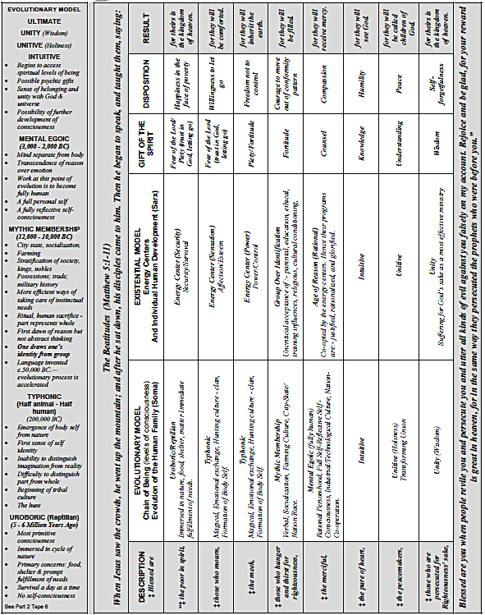

affecting them too much on the emotional plane. In other words, they don’t draw their identity from what other people say or think but are self-actualizing. And the fortitude that belongs to the meek is the fortitude that stands firm in the face of opposition without running away, instead of fighting back. As St. Thomas Aquinas says, this requires greater courage than fighting back, to have the patience to hold one’s ground and to be criticized, insulted, have rocks thrown at you, and so on, if that is the way it is. This leads then, to an experience of the passion of Christ and that inner understanding of what it means that is an experience drawn from one’s own struggles with life and not just an abstract reading of the Gospels. In other words, the beatitudes are an assimilation of the values of Christ and of the Gospel. And thus, they become one’s own and one understands them, the Gospel and the teaching of Jesus from inside by personal experience. And not just spiritual consolation, but the even greater experience of struggling with the difficulties of life with dependence on Christ but without necessarily feeling his encouragement or consolation. Standing on one’s own two feet, in other words, and believing in God’s help without demanding that it be felt.

I think we can say, then, that these first four beatitudes enable us to graduate from the childish programs, once and for all. And now to move into those higher levels of happiness and freedom that the Gospel invites us to. These beatitudes are preliminaries to the real work that is waiting to be done — the inner work of freedom from selfishness — and openness and sensitivity to the movements of the Spirit that are inviting us not just to generous efforts, but, where needed, heroic service of God and other people.

Blessed are the merciful, for they will receive mercy.
The beatitude, then, that corresponds to the full reflective self-consciousness of the Mental Egoic level is the beatitude of the Merciful: “Blessed — Oh, how happy you’ll be if you show mercy, forgiveness and compassion because you will then receive the same.” And as Jesus says in another place, “in ever increasing abundance.” This is the level when we have begun to become fully human. And the fully human response to life is not competition, but co-operation, harmony, bonding, unifying with others, negotiating, and where this is impossible, accepting people as they are without trying to change them. This is beginning to fulfill the commandment to “love one another as I have loved you,” Christ’s great commandment, which is much more profound and demanding than the commandment to love our neighbor as ourselves. This goes a lot farther. To love our neighbor as ourselves is to perceive the divine life in them and to respect the image of God in our neighbor with the rights and dignity that confers. To love one another as Jesus has loved us is to love one another in our humanness, individuality, in our opinionated-ness, in the things that drive you up the wall, in the personality conflicts. In other words, it’s to put up with this guy or this person with love and to continue to show love no matter what the provocation may be in the opposite direction for us coming from them. This is great freedom indeed — not to react in kind out of compulsivity, to attack, insult, abuse, or whatever.

Again, it’s not a passive attitude. And hence, those who have suffered oppression have to be a little careful with some of the beatitudes, that they don’t take as too passive or give too passive a meaning to some of these wisdom sayings of Jesus in which he urges us to accept what is. He always wants us to be ready to do something about the situation once we’ve accepted it. The choice, then, or the discretion that has to develop as we gain freedom of choice from our compulsions and can decide what to do, is to listen carefully to the inspirations of the Spirit to see if we are called simply to endure something for the love of God, or not only to endure it, but to do something about it.

The merciful, then, are those who have this universal compassion, which is beginning to expand beyond family, loved ones, into the community and ultimately into the whole human family — past, present, and to come.

The ultimate project of Jesus is to engage us in the redemption of the world and in sacrificing ourselves for that redemption after his example. So that to love more greatly, to be more concerned, is the way that the beatitudes are imparting the happiness of God which is to show his love and to make the sun shine on the good and the not so good and on those who respond and those who do not respond.

Another aspect that’s important at this level and which goes with this beatitude and which is something that we can do, is to also practice great compassion for ourselves.
It’s astonishing how important that is, especially in our time, when so many people have a low self-image and experience self-hatred, which is simply the pride system in reverse. Instead of reaching out for self-aggrandizement, for temperamental or other reasons such as continuous oppression, we reach out rather for the opposite: to hate ourselves because we don’t measure up to the idealized glory or perfection that our preconceived ideas require. And so, the pride system, not God, says, “You’re no good. You’re guilty of failing to measure up to these marvelous expectations that you’ve absorbed either from the culture or from your own bright ideas.” The human condition is what we’ve described. And most of us bring with us this heavy background of emotional junk from early childhood which has to be evacuated and which is being healed by the Spirit ever so gently, ever so gradually, but firmly, if you give it time. It’s a process of healing and of growth. And to the degree of the healing, the growth instantly takes place, because such is the nature of the human condition. Once it’s free to grow, it functions. It’s only the straitjacket of the false-self system that squeezes it into an infinitesimal use of the potentialities of the human energies instead of enabling them to expand and to begin to access the higher levels of consciousness, happiness and faith.

Now at this level, notice these three columns are arranged advisedly, more or less in tandem, [runs hand across chart on a level horizontal plane] and so on the Mental Egoic level, there corresponds this developing level of prayer. So that one of the activities that we are responsible for, in this co-operating with divine transformation, is to develop the devotion and dedication to God that comes through prayer. And prayer as a relationship, then, as we saw, becomes more intimate, more of a resting in God’s presence. And at that point, as we saw, the Night of Sense begins in which the divine action becomes more powerful in reaching down into the depths of our spirit, our psyche, to heal it, to unload the emotional damage or junk of a lifetime and to free our listening apparatus, so that we can hear and assimilate the message of divine love that is coming to us all the time, but which, because of the static, we’re not hearing too well.

Notice that there’s a transition here between going to God through reason and particular acts, to going to him more directly at this level of our faculties, which is the passive intellect and the will to God, which is our openness or capacity for unlimited truth, unlimited love, and unlimited happiness. The will, now, receives God more directly from within instead of his approaching us through the senses, through the memory, imagination, reasoning, particular acts.

In other words, now we are in relationship to God, Being to being, Spirit to spirit, cheek to jowl, face to face, so to speak. And to facilitate that new relationship there comes, then, an experience of transition, a crisis of faith as we move from the Mental Egoic level to the Intuitive level. Once on the Intuitive level, which is a higher perspective on reality, then all our relationships change towards ourselves, towards God, towards other people, towards the cosmos, etc. And we then spend a period of time integrating and adjusting ourselves and all our faculties to this new experience or level of being.

Blessed are the pure in heart, for they will see God.
And the beatitude that corresponds to the Intuitive level is the beatitude of the pure of heart. And the promise is, “they will see God.” Not with bodily eyes, of course, but with the x-ray eye of faith that is purified in the Night of Sense and which now penetrates through experiences and touches the reality of the symbols whether they’re rituals or sacraments or even nature itself. All of which become more transparent of the mystery that is manifesting itself in more or less degree through each of those channels. In other words, our sensitivity to the message of divine love that is beamed to the whole universe is sensitizing us to how it speaks to every creature at every level of its being. Now the flowers, the leaves, the sunset, friendship, the service of others, nature, art, music, other people, even ourselves, begin to speak to us of the mystery of God and the happiness that arises from this proximity or belonging to the universe — nothing can match. Again, it may be manifested by experiences such as we saw in referring to the stages of felt contemplation. The intuitive experience may deepen with ever-increasing absorption in the love and the presence of God during prayer, as well as sensitize us to this Presence in daily life, in events and in other people.

The Intuitive level, as we saw, is that energy now that’s released, which sometimes gives rise to psychic powers, charismatic gifts and spiritual consolations of a significant and sometimes monumental character. And so, there’s a tendency, then, because of the wonderful character of these graces, or the extraordinariness of psychic gifts, or the adulation of our admirers, that one suddenly realizes that it’s not so hard to take a certain secret satisfaction in all of this. And so, one needs the purity of heart, that is humility, to let go of that satisfaction as it arises and warns us that we still have a long way to go in the Night of Sense to be like God who is totally self-giving and self-forgetful.

So now, having exercised this level and experienced the beatitude of perceiving God through faith in ourselves — others, now there comes another transition, another crisis of faith. Only this time it’s perhaps more a crisis of trust, or more exactly, a crisis of love in which we feel called into divine union and one identifies with other human beings and with their sorrow and with their suffering, and it’s impossible to experience perfect joy as long as that concern is very lively and poignant. But in the Dark Night the emotions are finally integrated, as we saw, into reason and faith, and their tendency to dominate our thinking, our attitudes, and our motivation simply ceases. And one moves through the transition of the Night of Spirit, as we described it earlier, into the restructuring of consciousness that takes place at the Unitive level of consciousness, or what is called in the Christian tradition, Transforming Union.

Blessed are the peacemakers, for they will be called children of God.
And this is the beatitude of the peacemakers. These are peacemakers not so much because they demonstrate (although this is useful perhaps) or run all over the world, or preach it, but, more important, they have become peacemakers in their inmost being by establishing, through their sensitivity to the Spirit, peace within themselves. Now, peace in the classical definition is the tranquility of order. And the order of human nature consists in the effective subordination and integration of the emotional life/our rational life into our intuitive life — and the submission of this unified human being that has become whole, with the person of Christ, and the identification that takes place in that divine union in which the big “I” of Jesus Christ becomes our “I” — that is, our identity is now in Christ and no longer in our own interests alone. And if we have interests, we’re always ready to give them up at the prompt request of the one with whom we are in union and who is the senior partner, so to speak, of the firm.

Peace is the great gift of Jesus on the day of his Resurrection if you recall. The peace that Jesus offers is not something sentimental or emotional. If it has an emotional factor, that’s not the major part. Because this peace transcends the emotions and the opposites that the emotions present of joy and sorrow, hope and despair. It’s being rooted in a life, in a Presence, in a way of being that is deeper than the emotions. Hence, it is not swayed by the winds and the waves. It is not blown over by the floods. It’s a house that is built on a rock and the rock is faith in Christ. And that rock and that rootedness is strength against all storms because now the divine union has become an invincible conviction, a way of being, a fourth dimension in which all of reality is present. And the three-dimensional world is now only a part of reality because its greatest part has become available to the x-ray eye of faith and, more importantly, to the compassion which expresses itself in service and love of every creature. This is what characterizes the Ultimate Reality. So that entering into union with God means that one is becoming God-like, which is quite different from becoming God. Sometimes the spiritual consolation in these states prior to the Night of Spirit are so fantastic that one feels as if one were God. And such experiences, St. John of the Cross says, can be even stronger in the Transforming Union. Yet, the tendency in the Transforming Union, as it becomes an abiding state, is to do without those extraordinary graces or experiences, and to become more and more ordinary, and to be able to lead daily life without being especially noticed. Although, if one has special powers, these must be exercised. Still one is completely free of the results or does not draw one’s identity from any kind of glamorous role, but is simply, like God, the servant of creation.

Blessed are those who are persecuted for righteousness’ sake, for theirs is the kingdom of heaven.
There’s a final beatitude, the eighth beatitude, and that belongs to another stage of consciousness, the stage of wisdom in its fullest sense. And this is the wisdom that finds happiness in persecution. “How happy,” Jesus says, “you will be if everybody just says the worst things they can think of about you, if you suffer for the truth or for justice or for my name — Oh, dance for joy, your reward is so great — you don’t know what to do with it!” In other words, jump for joy! That’s the peak of happiness in this extraordinary worldview of Jesus. I don’t see too many jumping around in that condition. It’s all people can do to hang in there and not get angry at their oppressors and to try to forgive. But this is not the beatitude. When Jesus says, “This is happiness,” it really is! Because now one has moved beyond self-interest to such a degree that one no longer possesses not only things, or one’s body, or one’s own will and judgment, but no longer has a possessive attitude towards the self or one’s identity, because one’s identity is rooted in Christ and whatever unique mission or identity he wants you to have, and if that happens to be suffering, swell. There’s no sweat, because one’s whole happiness has become centered in the truth. And one perceives that in persecution, one is actually serving in the most decisive and perhaps effective way of all the means of exercising ministry.

In the experience of union, one not only enters into the peace of Christ, but becomes oneself a transmitter of the divine life. This energy that God has given us is being transmitted constantly to those with whom we live and love and beyond. As even the physicists say, you can’t have a thought without the rest of the universe being instantly affected. And so, if you have the divine life, at every instant you are pouring this energy of life, light and love that you have received and that has been established in your inmost being, into the universe and healing the negative vibrations of the atmosphere, and allowing God to be God and those who are seeking him to access him whether you speak or whether you are silent.

There is a final stage in which, at this level [points to chart: “Stages of Prayer, Night of Self, Unity”], we are self-forgetful. How much you are self-forgetful, I leave to your experience. Without getting into that controversy, I simply say — the choice is now yours.

