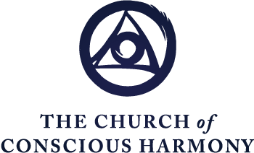

The Spiritual Journey
Formation in the Contemplative Christian Life
“The Beatitudes: Healing the Emotional Programs, Part 1”
Excerpted from
The Spiritual Journey Part 4, Paradigms of the Spiritual Journey

Fr. Thomas Keating

Perhaps a more comprehensive way, or an alternate way at least, is to present Christian transformation from the perspective of the Beatitudes. The Beatitudes are the quintessence of the teaching of Jesus. They represent his idea of happiness, his worldview. They are the fruit of his sacrifice and the outpouring of the Spirit whom he has given to us in the Pentecostal grace. We all have within us in virtue of the Baptismal grace these Gifts of the Spirit, which are waiting to be activated by the process of letting go or dismantling the straitjacket of the false-self system which prevents us from hearing the delicate inspirations of the Spirit.

The Spirit, then, cannot compete with this noise, and it’s like static in the receptive apparatus of a radio set. Until the static calms down and is quieted, you can’t hear the news of what the announcer is going to say, or if you do, you just catch a word here and there. As the static or the noise, the false-self system with its turmoil and emotional distress, calms down and diminishes through contemplative prayer and the active practice of virtue, then, little by little, the message of the Gospel, or more exactly, the higher transmissions of the universe, begin to be heard with greater and increasing clarity.

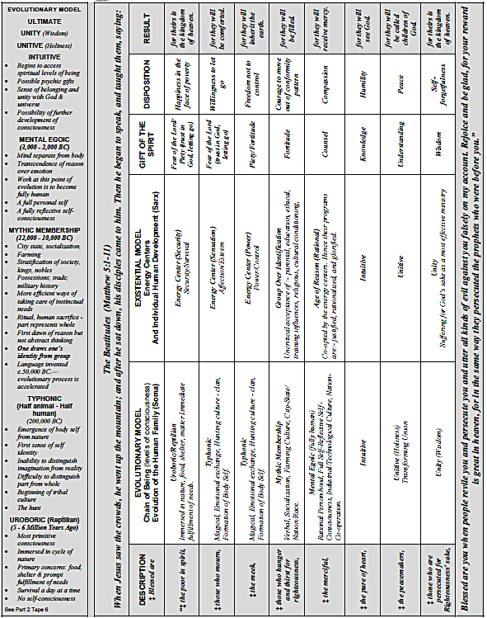

The Beatitudes describe what happens through the healing of the Holy Spirit, healing each level of human consciousness through which we have passed. Then it continues to unfold the potentialities which the spiritual journey opens up and which our sensitivity to the inspirations of the Spirit now permit once the static has subsided and the messages from the truth and the love of God begin to be heard interiorly and responded to.

The object, then, of Jesus and the spiritual journey is to heal us. As he said, “I am the Good Physician ... and I’ve come to heal the sick and not those who don’t need a doctor.” He knows what the human condition is. And the gift of the Spirit initiates this healing process which touches each level of consciousness that we pass through, brings out its basic goodness, and heals its limitations and the wounds that were gathered through the vicissitudes of growing up.

Blessed are the poor in spirit, for theirs is the kingdom of heaven.

Let’s look at how the Beatitudes address the human condition at each level and what the traditional means of initiating that healing is, and how each Beatitude completes it, by manifesting the happiness that is appropriate for that stage of human development once it has been healed from its limitations. The first Beatitude deals directly with the very first level of consciousness that we experience on coming into the world with the reptilian or Uroboric consciousness, which is really a level of no consciousness. And the chief interest, if you recall, of Uroboric consciousness is food, matter, earth, shelter, and the prompt fulfillment of physical, emotional needs. The Beatitude addresses this human condition, which is basically good, but which because of the privations of early childhood has developed into an energy center, the source of motivation, which has a drive now for symbols of security in the culture or wherever it can find it. Hence, it’s a much more elaborate drive for security than the infant experienced because of the development of other powers, both emotional and rational, of human development.

So “blessed” — “O how happy you would be!” Jesus says, “if you were poor in spirit, if you put your trust in God rather than in possessions and symbols of security, which, in actual fact, you will never be satisfied with, because the demand, the energy center for security and survival, is fantastic and unlimited. Hence, it’s really a program for human misery since it’s bound to be frustrated.” The poor in spirit, as understood in the Gospel, are those who are afflicted for God’s sake. They are not only the materially poor, but certainly they are people who are destitute and poor. But they also are those who suffer any human affliction: emotional, mental, or whatever, and who accept that situation out of love of God. It’s the Spirit that is suggesting this acceptance of what it is, or the reality of the situation with trust in God. Hence it could be that the gift of the Spirit that is called the gift of Piety, which puts its trust in God and in Divine Providence, rather than in what the symbols of security in the culture, whatever those are, can provide.

This attitude of happiness in the face of destitution, poverty and affliction, is the fruit of letting go and of acceptance of what is. But it’s not just a passive acceptance. The eighth Beatitude is the “Beatitude of those who are persecuted for the truth or for God’s sake.” And their reward is exactly the same as that offered in the first Beatitude; namely, “the Kingdom will be yours.” In other words, by accepting reality and events, one is free of the predetermined goals and demands and “shoulds.” And thus if one has little or nothing, there isn’t the struggle to let go of what one has; and thus the poor, in a sense, have a special claim on the Kingdom because they literally don’t have anything else, or — if they have other possessions — they, through the grace of God, are willing to let them go, if the needs of others or the will of God requires that of them.

As we saw, if the persecuted also enjoy the Kingdom, then this alerts us to the fact that poverty of spirit is not simply a blind and passive acceptance of whatever happens. It also presupposes our willingness to do something about the situation to correct it if God should so inspire us. No one is persecuted for doing nothing. Hence, the fact that one has the same reward when one is persecuted, suggests that although we accept what is as a preliminary disposition, we also are alert to the fact that God may be asking us, once we’ve accepted the reality of the facts, to do something to change, improve, or correct the situation, including, possibly, defending ourselves or others when this is called for.

These Beatitudes are not absolutes, but they are wisdom sayings that express a disposition that’s appropriate to each level of consciousness and which recognizes both the goodness and the limitations of each stage of human development. This, incidentally, is the heart of Christian ascesis. The physician doesn’t heal people by killing them. We do not heal the wounds of childhood or the emotional programs for happiness by destroying the instinct itself, but rather we free what was good in this instinctual need. The biological need for survival is essential to keep going in this world when things are tough. It’s only the limitations, the distortions, the malformation that the grace of the Spirit is healing in order to enable that level of consciousness. Once it is healed and brought into reasonable proportions, it can be integrated and contribute to the ongoing health and wholeness of the human organism with all of its potentialities.

Blessed are those who mourn, for they will be comforted.

Christian tradition has given us some other means to get started in healing. And this is what we mean by a “discipline” — for instance, fasting, vigils, simplicity of lifestyle; all of these are helpful disciplines, obviously, because they’re addressed to what interests the Uroboric level of consciousness. It likes to eat. It likes its needs promptly fulfilled. It wants to be secure and to feel secure. So, by upsetting that comfortable expectation of always having one’s food and sleep and shelter thoroughly provided, a little upset situation begins to awaken in us the possibility that we’re not as dependent on these things as we have thought. It’s this effort of our own to practice a little bit of dismantling as a preliminary to the movement of the Spirit to reinforce our efforts that is called the “Active Night of Sense” by John of the Cross. And it’s in response to those efforts that the Night of Sense, which is God’s passive purification, goes far beyond any effort that we could go in freeing up that level of consciousness from its hang-ups.

The second level of developing human consciousness is the Typhonic consciousness, that half-human, half-animal consciousness, in which the emotional life of the child develops. And here we saw that two aspects of that same level of consciousness develop into energy centers if they experience privation or the felt loss of something that they felt was essential. And that consists in a sensation center which develops out of our affection, esteem and pleasure needs, or the power/control center which develops out of our need for independence or the willfulness of the child that expresses what he wants or doesn’t want fairly clearly, emphasized by a loud shout.

Now two Beatitudes address those centers of energy. The Beatitude here is “Blessed,” or, in other words, “How happy.” That’s what the term “blessed” means: “Oh, you’d be so happy if you would learn how to mourn, for then for sure, you’ll be comforted.” When we let go of anything (person, place or thing) that we love, you automatically and emotionally go into a period of mourning. And it’s only the refusal to let go of what is taken from us that creates the tension. When we mourn and accept the mourning and accept the loss of what is gone, then we begin to be restored to a new level of freedom because what we formerly depended upon too much has now been modified or subsided or brought to reasonable proportion. And we can enter into a new relationship with the things we had before based on a new freedom that does not try to squeeze from pleasure the happiness that it is not created to give. That’s the source of frustration: to demand from the legitimate pleasures of life an absolute happiness. This is idolatry. This is making this particular pleasure or experience an idol, something to substitute for the happiness that we are not experiencing from union with God. That’s the human condition. Each one of these energy centers develops in the context of isolation and in the consciousness of an identity, a self-consciousness, that is developing without the experience and reassurance of divine union. So, each time we move to a new level of self-consciousness, we move to a new level of fear, dread, isolation, alienation that comes from the separate-self sense. This is what the Spirit of God is trying to heal, along with the damage that developed because of our ways of coping with these impossible situations.

Here again, the tradition has a few classical ways of dealing with the pleasure center. One of these is the practice of celibacy, whether temporarily or permanently: various forms of bodily restraint, work in the service of our community, manual labor in which one puts forth physical energy and thus develops a certain control over the bodily impulses. All of this is just the beginning of a feeble effort of ours to try to reduce our over-dependency on the goals of that particular level of desire or energy.

Blessed are the meek, for they will inherit the earth.
Let’s look now at the power-control center, also developing in the Typhonic consciousness. And here the Beatitude is, “Oh, how happy you would be if you don’t want to have control over anybody, dominate situations, other people and try to control your life and events and even God, if you could get away with it!”

Here the happiness consists of the freedom to be able to accept insults, injustice, without being blown away and to get along with people whom you don’t like, or whom your chemistry doesn’t seem to agree too well, or who drive you up the wall.

One of the great traditional means of working this distortion or malformation out of our system is the vigorous practice of serving others, of fraternal charity, that is, of trying to accept people as they are without trying to change them, to show love, to minister to their needs, and hence, all the corporal works of mercy, healing the sick, or taking care of the sick and all the forms of physical, mental, or spiritual therapy.

Blessed are those who hunger and thirst for righteousness, for they will be filled.
The fourth stage of our development, then, moves out of these childish programs for happiness and brings them into a new dimension which is the social development that takes place from four to seven, roughly, in which we absorb the value system of parents, teachers, important others, the culture, peer group, and I suppose, today, the television programs. The child, then, doesn’t have a reason functioning yet to evaluate all these programs, so that it absorbs them all unquestioningly and it relates its emotional programs for happiness to this new social situation. So now this is what we mean by the development of the home-made self or the self-made self. The programs that we used to cope with impossible or difficult situations are now extended on this vast horizon of social relationships that makes them all vastly more complex and intricate.

Now here the Beatitude is going to address that over-identification with a view of freeing us from too great a dependence on social pressure, from human respect, from wanting to belong to the group to such a degree that we do not respond to the request of the Gospel to go beyond the conformity level of morality or the respectable behavior that may be an honor in a particular peer group that we might be in. This is the Beatitude: “Blessed are those who hunger and thirst for justice. They will have their fill.” That is to say: this is the grace of the Spirit that gives us the courage to move beyond or out of our conformity patterns and to be prepared to follow the Gospel into our personal response to Christ and not to a response that is merely based on what others say, do, or expect of us.

Notice how the Beatitudes are all directed to one project — inner freedom — freeing us from the fascination of programs for happiness that are doomed to failure, freeing us from an over-dependency on unquestioning values, what might be called pre-packaged values, preconceived ideas. This is especially interesting from the perspective of commitment. Whenever one makes oneself vulnerable, which is the case if you enter into a relationship of friendship or love with somebody else, usually stirs up in some degree the sexual energy. Now it’s the commitment to one’s married engagement, if one already has one, or one’s celibate engagement, if one has that, that gets one through the process of self-knowledge and enables one to hold to one’s commitment and at the same time to benefit from this new relationship.

In other words, suppose that one becomes aware through the process of self-knowledge, that one’s motives for entering a marriage, let us say, were much too human: maybe we were looking for a mama, if you will, that we never had as a child. And so, we saw in this very capable person who took care of all our needs, did our wash, fed us every day, and dried our tears, and we could weep on her shoulder, and suddenly it dawns on us as we are progressing in prayer and in self-knowledge, that this really wasn’t the right motive to marry this good person. And so, the thought comes “Well, to gain my freedom, I have to sever this relationship completely.”

It’s the commitment that says, “Take it easy, Pal. Bring your new insight back into the relationship and make it work from the new attitude that you have achieved.” It is not always so easy because sometimes one is aware that one has such a dependency, that just being with this other person who fulfils all these needs so graciously, is preventing one from breaking out into freedom, and that you think, “I must leave, separate for a time, in order to establish the habit of freedom and personal autonomy.” That may be the case in some cases where there was a mistake made, but the commitment enables us, at least, to go slow and to try to bring the new insight into the original commitment.

No one enters commitments, including the religious life or priesthood, with completely pure motives, because if they did, they would already have to be here, at the Transforming Union [points to chart]. And so, it is not so much what motive we had in entering, as long as we were sincere on the commitment. It’s what is our motive for persevering NOW and to try to exercise the right motive right now.

We see, then, in these first four Beatitudes what corresponds really to the commandment to love our neighbor as ourselves. Because it is through these Beatitudes that we finally let go of those demands or needs which, when frustrated, tend to push us to disregard or despise or neglect the needs or rights of other people. And when we ratify such attitudes, this is what leads to personal sin. And so, these first four Beatitudes are preparing us to graduate from our childish programs for happiness and our over-dependency on our early relationships so that we may begin to hear the Word of God in the Gospel addressing our hearts and to respond now with the kind of freedom that will enable us to negotiate the higher levels of consciousness.

